4-BIT REGISTER MINI PROJECT

Design (member a)

1. Input and Output Signals
Signal | Description
Clk | Clock input
rst | Reset input
s1, s0 | Operation selection inputs
sin_right | Serial input during right shift
sin_left | Serial input during left shift
q[3:0] | Four-bit register output

2. Function Table
S1 | S0 | Operation | Description
0 | 0 | Hold | Retains the current register value
0 | 1 | Complement | Inverts all four register bits
1 | 0 | Shift Right | Shifts bits toward the least significant bit
1 | 1 | Shift Left | Shifts bits toward the most significant bit

Next-State Equations
Let Q3, Q2, Q1 and Q0 represent the current register bits. Let Q3⁺, Q2⁺, Q1⁺ and Q0⁺ represent their next values.
Hold — S1S0 = 00
- Q3⁺ = Q3
- Q2⁺ = Q2
- Q1⁺ = Q1
- Q0⁺ = Q0
Complement — S1S0 = 01
- Q3⁺ = NOT Q3
- Q2⁺ = NOT Q2
- Q1⁺ = NOT Q1
- Q0⁺ = NOT Q0
Shift Right — S1S0 = 10
- Q3⁺ = sin_right
- Q2⁺ = Q3
- Q1⁺ = Q2
- Q0⁺ = Q1
Shift Left — S1S0 = 11
- Q3⁺ = Q2
- Q2⁺ = Q1
- Q1⁺ = Q0
- Q0⁺ = sin_left

3. MUX Input Mapping
Each 4×1 multiplexer has four data inputs and two select inputs. The select inputs determine which data input reaches the output.
S1 | S0 | Selected input
0 | 0 | I0
0 | 1 | I1
1 | 0 | I2
1 | 1 | I3

Data Inputs for Each Multiplexer
Multiplexer | I0 — Hold | I1 — Complement | I2 — Shift Right | I3 — Shift Left
MUX Q3 | Q3 | Q3’ | sin_right | Q2
MUX Q2 | Q2 | Q2’ | Q3 | Q1
MUX Q1 | Q1 | Q1’ | Q2 | Q0
MUX Q0 | Q0 | Q0’ | Q1 | sin_left

4. Boolean Equations
The general Boolean equation for a 4×1 multiplexer is:
D = I0 S1’S0’+ I1 S1’S0 + I2 S1S0’+ I3S1S0

D3 = Q3 S1’ S0’+ Q3’ S1’S0 + sin_right·S1S0’+ Q2 S1S0
D2 = Q2 S1’ S0’ + Q2’ S1’S0 + Q3 S1 S0’+ Q1 S1S0
D1 = Q1 S1’ S0’ + Q1’ S1’S0 + Q2 S1S0’ + Q0 S1S0
D0 = Q0 S1’ S0’ + Q0’ S1’S0 + Q1S1 S0’ + sin_left·S1S0

Here, D3, D2, D1 and D0 are the inputs to the four D flip-flops.

6. Block Diagram

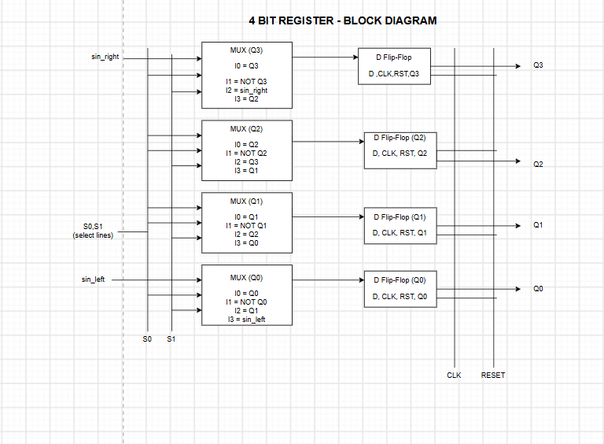

7. circuit diagram

